Appendix 4

The Mark W. Gray Interview – 2007
A lot of times the guy at the bottom is the person who knows what’s really going on

Introduction

Mark Gray is E.V. Gray’s 3rd child born in1958 in southern California. For the past several years he has been a parts room manager for a school district repair shop that maintains over 200 busses. He is a single parent who currently lives with his three young adult children. (Two daughters and one son).

Mark Gray was employed by his father E.V. Gray for the majority of time between 1979 and early 1988. In this time period he served in the capacity of a general assistant. He traveled and worked at 7 different locations, including a two week trip to Israel.

Under his father’s direction he assisted in the building of a majority of the “Trigger Carts” (The converter systems under the pulse motors) that are displayed in the 1896 ZTEX promotion video. He also assisted in securing parts from custom vendors, video taped the technology, assisted with various demonstrations, did some fabrication, and wrote licensing agreements. These are just a few of the multitude of tasks he did during his tenure of service.

Mark parted on good terms from his father in early 1988 when funding ran out due to differences between E.V. Gray and certain investors on the control and future of the technology. This differences were accelerated when an alleged government contact, interested in a possible R&D program on the switching/triggering aspect of the technology, came into the picture late 1987 – early 1988.

While Mark had a tremendous exposure to his father’s later technology (1979-1988), his detailed understanding of the underlying functioning principles is almost gone. He did what he was told to do and was compensated appropriately for his services, but never got deeply involved with the workings of the technology. For the past twenty years Mark has been completely divorced from his father’s technology and has forgotten most everything he knew about it. He regrets not having paid more attention or not taking a real interest in the “nuts and bolts” of the processes.

Mark was most willing to share these anecdotal technical Tid-Bits that might have a bearing on rediscovering this lost technology.

General initial discussion about random subjects

Mark W. Gray – Phone Interview 5/1/2007

I asked him what it felt like to be working with an age-changing technology in his youth. He said that at the time he didn’t realize the power of the stuff his father was working with. He pretty much took it for granted at the time. He said he regrets not having paid more attention to what was really going on. But, since then his training in the automotive business has shown him what he missed. Mark is now up on batteries, their ratings, and typical electrical performance. He now knows what kind of batteries his father was working with (Group #31). He described an experiment that he and his father performed with the multi-demo cart. They were doing a load study to see how much current they could extract from the system before running the batteries dead. He described the connections to the load banks of incandescent household bulbs and how they switched from load to load. Apparently they were drawing 200 Amps continuously for quite a long time. Back then he had no idea what that data meant. Now he realizes that they were extracting way more energy that what the batteries could hold.

With this insight I didn’t bother asking about what he thought of the plastic magnetic projectiles. Unless a person had some training in physics (or mass drivers) and had taken time to do some basic calculations they wouldn’t have a clue as to the huge forces involved in those demonstrations of 1986.

I asked if he had any idea as to what was the process was that resulted in all this excess energy. He said he had some ideas. I felt that he would have shared them at the moment, but he needed a napkin to make some sketches. A phone conversation certainly has its limitations in certain kinds of communication.

Mark said that during this decade (1978 to 1986) his father had in his employ an electrical technician who developed most of the electronics. His name was Nelson Schlaft “Rocky”. He has no idea what ever happened to him [He was living in Palmdale, CA]. Apparently it was just EV Gray and Mr. Schlaft who worked at the Council facility.

I asked several questions about where and how all the equipment displayed in the promotion videos was made. Since Council was such a small town (population of 816 in 2000) I figured that the local machine shop was kept in business just making parts for the local Mad Scientist. Mark didn’t have a definitive explanation. It’s like he never given much thought to that idea, which is typical for a young man that age. (At least it was for me). He seemed to think that most of the equipment was made in California and then shipped to Council. Or some work may have been done in Boise, ID. He didn’t think that much, if any, was done locally. [Historically it has been determined that the Pulse Motors were built in the early 60’s. Mark Gray and Nelson Schlaft built the Trigger Cart and the Meter Cart which still required a lot of parts.]

Mark said his father had an “S7” truck to load up his demonstration carts in. Then he wondered who got the truck after his father’s death. EV Gray used this truck to bring equipment in from California and go on investor demonstrations.

I asked where the laboratory was located. He said it was in the middle of town on the main drag. He had a shop front that he used as an office with an apartment upstairs and a steel building out back. This was where the videos were taken. He thought that a government agency has bought the property after he had left and made it into a welfare or social services office. He didn’t recall the address, but said it shouldn’t too hard to find since the town is only about three blocks long.

Council, ID was originally a lumber mill town. When the mill closed the town died. I don’t know when that happened, so the town may have been bigger in 1986.

Mark seems to imply that he only worked with his father for about 10 years. He went on to pursue his own ambitions (raise his family) after they moved the laboratory to Grand Prairie, TX. Mark generalized his feeling of discomfort in this part of his experience. He described strange people coming around and the impending power conflicts as various groups vied for control of the technology. Apparently there were aggressive investors and different government representatives involved. I can imagine the subtle stress that could have developed as EV Gray’s technology had reached enough ears to arouse some interest from the establishment. The distribution of the Crosby reports as part of the sales literature probably was the main reason. Mark made a point that most people would have just sold to the highest cash bidder, but EV Gray wanted to keep control of his technology till the bitter end. Needless to say this complicated negotiations.

EV Gray developed a serious case of pneumonia about two years before he died (1989). After that he was on oxygen and almost crippled from lack of air. As his health declined he moved his shop to Sparks, NV. Here he under took a program of disassembling his machinery, least someone steal his “secret”. [It is un clear just what he had disassembles in this period since the E1, E2, and Trigger cart appear to be untouched.]

Mark claims, this if anyone knows the whole story it would be Dorothy, who was living with his father at the time. He didn’t know her last name [McPhillips] but says she married a Preacher and moved to Colorado. Mark’s account of his fathers’ death is the same as James’.

Apparently Dorothy offered to sell the family various items of EV Gray personal belongings after he died. Mark considered this to be out of line since he felt that many of those personal affects should have just been given to the family. He also heard that Dorothy was placed under house arrest when she went to the Cayman Islands.

Whatever memorabilia Mark had in the past he claims has been disposed of.

I inquired about what his opinion was about where the original source of this technology came from. He claims that when he was in the fourth grade there was a motor case in his fathers shop. This would be about 1969 and is consistent with Dr. James Gray’s reports. Mark also said that his father was prone to having sudden inspirational dreams in the evening that provided the technical guidance. (Shades of Edison) These episodes were intense enough that EV Gray would get up and make extensive notes. Mark agreed that there was no long history of electronics or late evening research in his father’s previous history.

I asked why EV Gray had originally set up shop in such a small town. Mark said that he had in laws living there [1St son Eddie]. However, to the best of his knowledge there are none left today.

Specific topic and Stories

A Trip to the Capacitor Vendor

Mark Gary recounted an experience he had when he was instructed to return some defective capacitors to a custom supplier in Thousand Oaks, CA.

The internal connection between the external capacitor terminal and the internal plates had opened up because the wire gauge was too small, thus causing it to fail. To explore this complaint first hand, then vendor opened up one defective unit with a can opener. Since the connection had been separated at this point there was still a substantial charge still left in the unit. There was an unexpected accidental discharge that caused a loud bang. Apparently the vendor quickly made repair modifications to all the returned capacitors at no charge. Mark reports that the plates were gray with layers of a white material in between them. The entire unit was filled with a thick clear gel. Mark Gray claims he recalls values of 500uF at 5 KV.

Commentary:

This type of construction implies a low inductance plate capacitor rather than the higher inductance rolled designs. The residual stored charge implies a low loss construction – most likely not an electrolytic design/ Another authority (Mr. Kenneth Hawkins) claims that E.V. Gray used Mica capacitors. Mica is a very good dielectric, but to achieve the high values reported (500 uF) it is highly unlikely that mica was used in these units because of the volume needed, perhaps modern polymers were employed.

The Trigger Cart

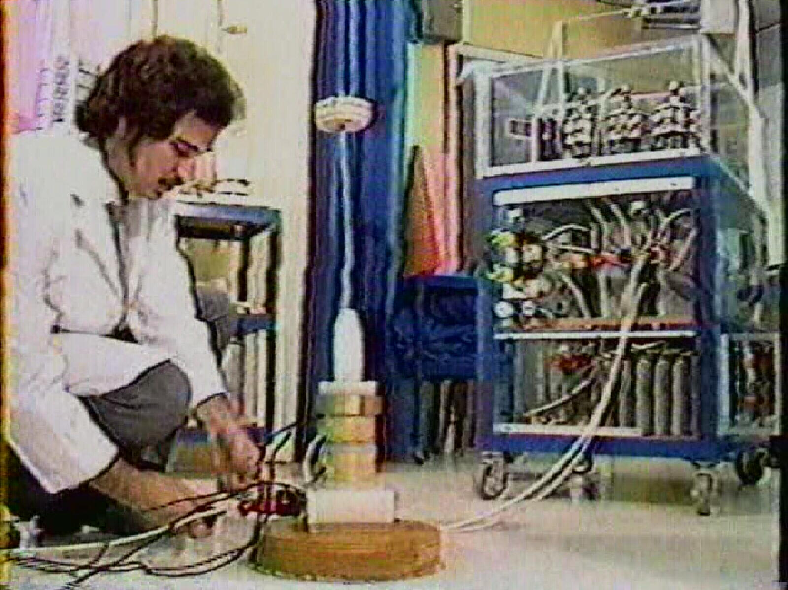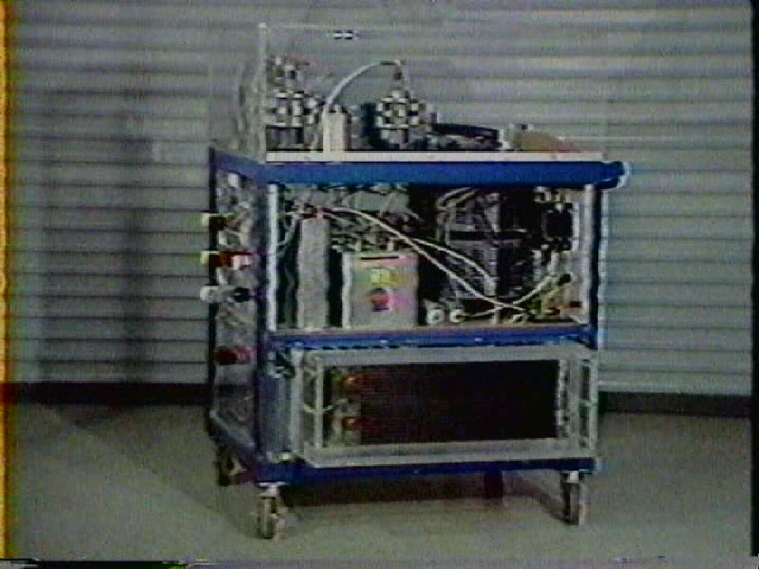

Mark Gray at 26 in Counsel, ID facility The “Trigger Cart” in 1986
up for bids in 2011 starting at $250,000

Mark Gray claims that the heart and soul of the E.V. Gray technology is the “Trigger Cart”. This is the power supply that was the source of the anomalous energy for all of the projectile demonstrations. What is interesting about this system is that I operated from 240 VAC, counter to all of E.V. Gray’s previous motors and circuits. Mark recounts how they were on a sales trip to the Kansas area and giving a demonstration in a school Gym. The available 240VAC circuit was not large enough to meet the power demands of the demonstrations. His father had to rent a 50 KW portable diesel generator to continue with the demonstration.

Trigger Cart operation: “I would slowly crank up the Auto-transformer until the tubes started to fire, then watch the volt meter. When it got to 5,000 volts I would quickly turn down the Auto-transformer and fire the projectile.

Auxiliary Capacitors: Mark Gray describe that there were additional storage capacitors that were plugged into the “Trigger Cart” depending upon what was being demonstrated. The Trigger Cart had some onboard capacitors but the capacitor bank on another cart had about three times as much.

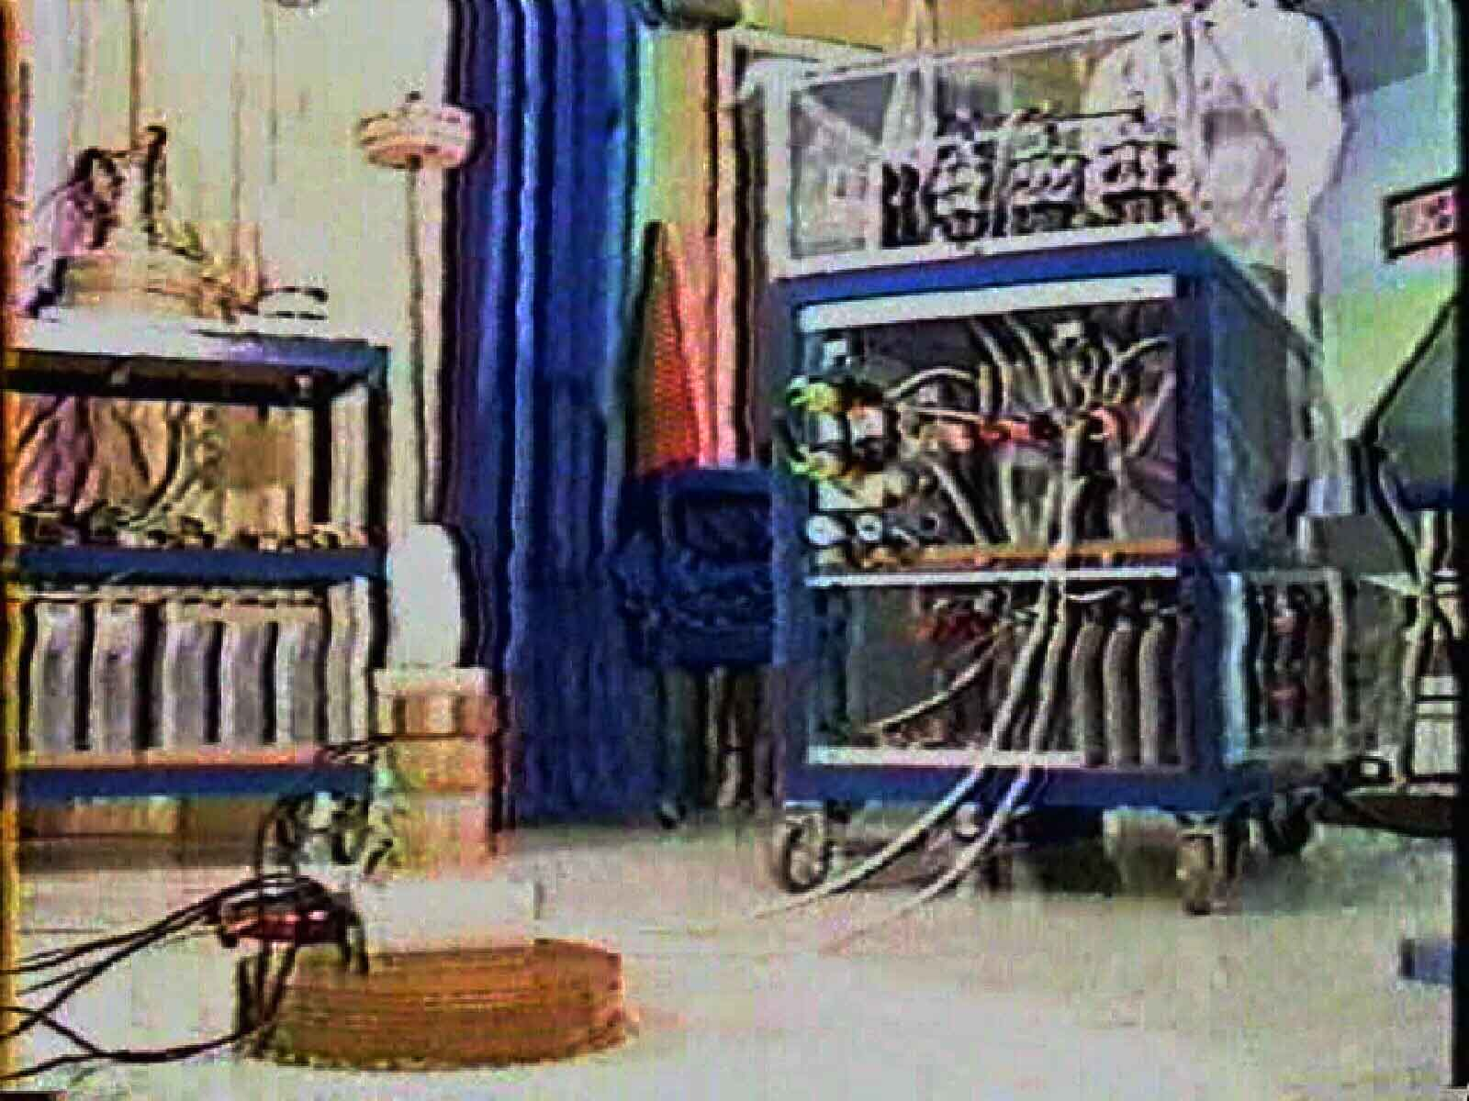

In this frame capture photo, note the “Projectile Cart” on the left. Six different types of projectiles are launched from this demonstration platform. The bottom of this cart contains a pretty substantial capacitor bank. You can see only 70% of the cart. This would imply that there are about 9 large capacitors in the first rank. If two rows are employed, then a total of 18 capacitors are present. For the sake of technical discussion it has been assumed that the total capacity of this array was around 1500 uF.

Mark Gray claims that this cart was in E.V.Gray’s possession at the time of his death. He plans to enquire among family members as to where this piece of equipment went. [The Trigger Cart and most everything else was acquired by Mr. Russell Audrey of Dodge City, KS and has been largely in storage since. The collection was being auctioned off in 2010-2011]

Commentary (2011)

The Trigger Cart turned out to be a huge 5KV linear power supply that consumed 25 KVA of power for some of the more demanding demonstrations like the “Hover” magnets. At this time in the E.V. Gray saga the demonstration equipment was no longer Over Unity, but had been modified in 1980 by Nelson Schlaft to operate on the brute force of line current. The modifications destroyed the original design and rendered the Pulse Motors useless. They then required about 10 KVA to rotate with no load. Never the less they still made good video props.
The huge amount of energy needed to launch the projectiles completely invalidates all of the technical claims that E.V. Gray was making in the 1986 promotion videos. Mark Gray seems to have had no idea as to what was going on in this time frame from an engineering standpoint. Mark Gray did say that on two occasions some military reviewers came to see demonstrations. Both of them reported to have said things like “your are insulting my intelligence by showing me this absurd & useless equipment”. After looking at the size of that capacitor bank and knowing the power level of the “Trigger Cart” it can be well understood why the reviewers would express such degrading opinions. It is probably correct to think that these embarrassing engineering details were not highlighted in the promotion videos or any written documents that accompanied their sales distribution.

The Mark I (Converter Switching Element Tube)
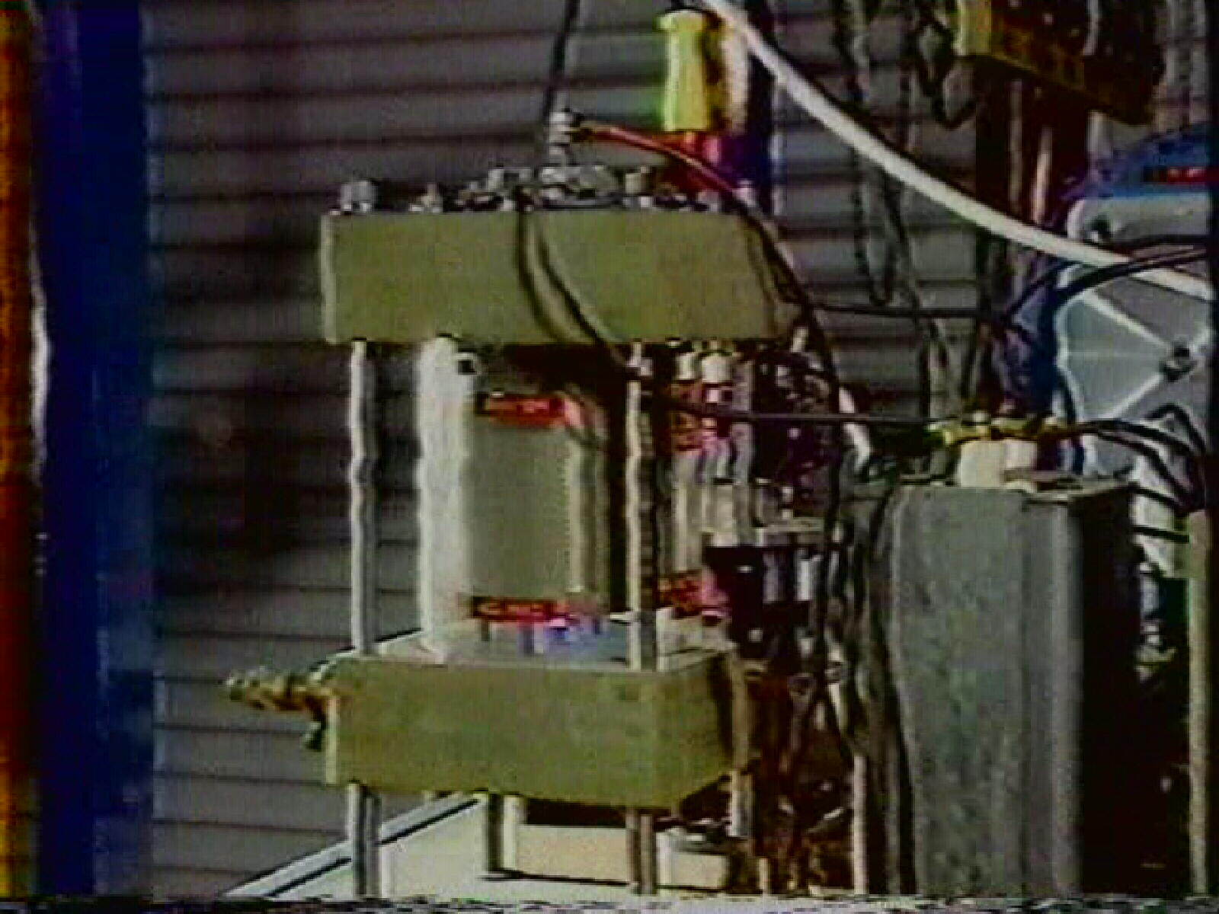

Mark Gray describes how he made trips to Boise, ID to a machine shop to get the two green end pieces made. It appears that these are constructed from G-10 a very expensive fiber glass impregnated high resistance thermosetting resin. When they were finished E.V. Gray groused about the cost (no doubt). A quote to machine clear cylinder was considered to expensive, thus an alternated was sought out.

● the cylindrical glass enclosure is a Colman gas lantern cover

COMMENTARY: This really limits the magnitude of the internal pressure of what ever gas may have been present. The size of the end caps could support pressures up to 6000 psi. With such a thin glass envelop anything over 3psi would be difficult.

“He didn’t want to pay the high price for a machined enclosure”

● all electrical connections were made from the top

COMMENTARY: I only see two electrical connections at the top of this device (the black center conductor and the white conductor with the large yellow single pin connector. Therefore the “Grid” is not connected to anything, unless it is to one of the electrodes.

● the gap was adjustable

● the internal gas was presumed to be Nitrogen from a welding supply house

COMMENTARY: Mr. E.V. Gray was very familiar with welding gasses

“He didn’t get involved with anything that exotic” (Referring to S6F)

● Purpose of the Grids: “Possibly to cover up something he didn’t want people to see?”

COMMENTARY: Like an additional series component, perhaps an HV RF coil?

● Was there an electrical connection to the “Grids”? “I don’t recall”

● “the electrodes were made of Tungsten or Titanium. Which ever material Russia is famous for.” [Titanium]

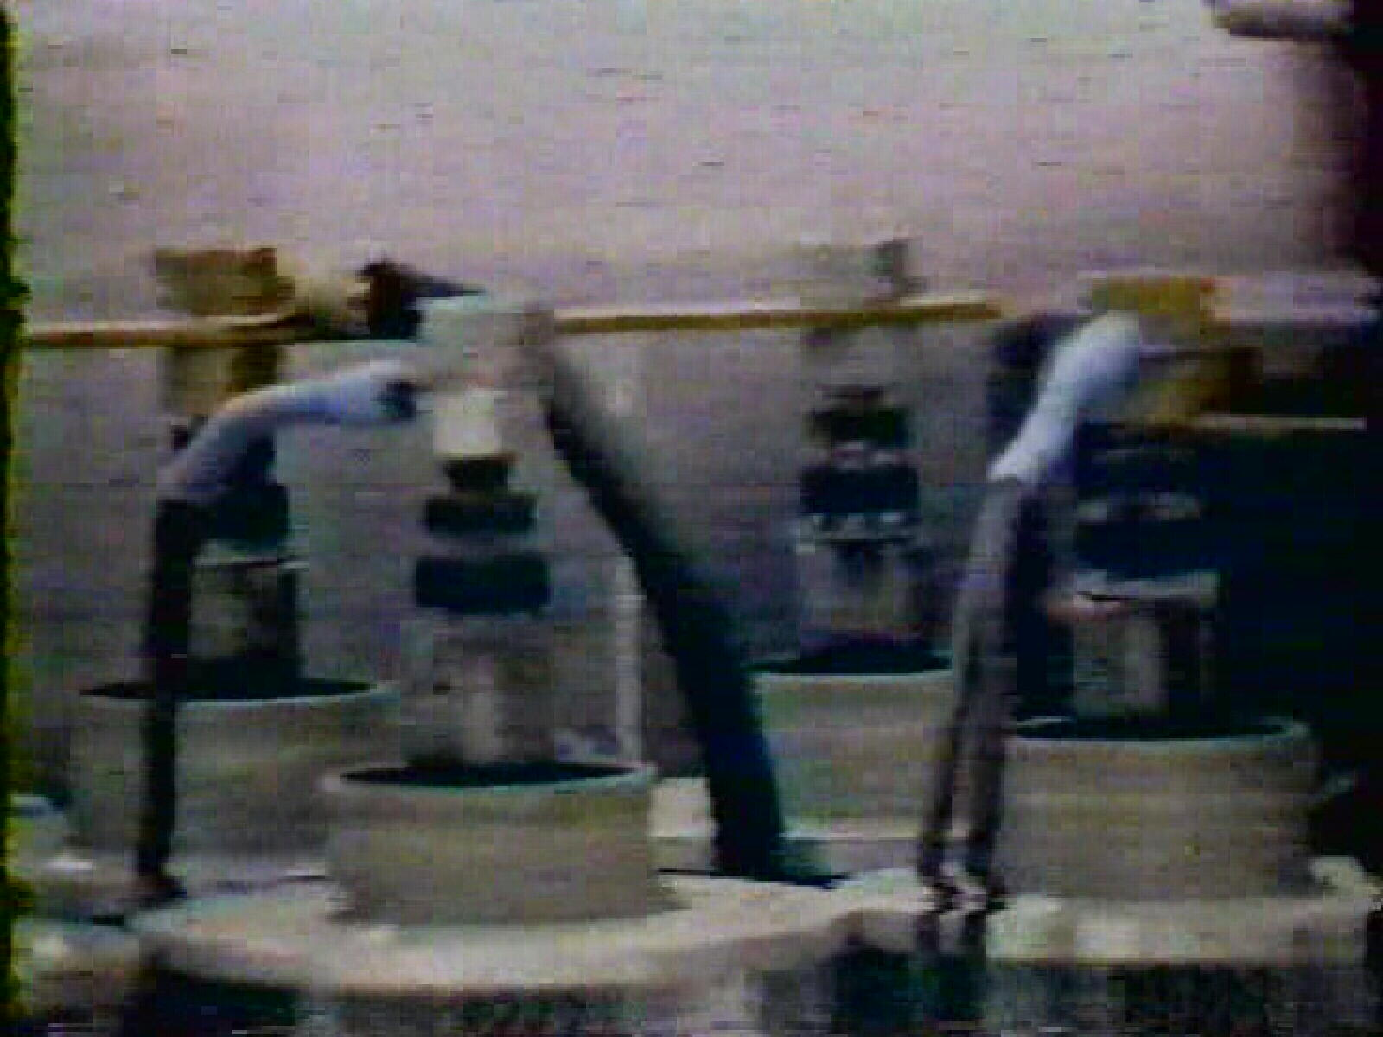

Ignitrons installed on the “Purple Motor Cart”

The Mark II “Silver Cylinder” (Ignitron)

● This was an off the shelf commercial device that was a metal cylinder about 2” in diameter and 6” long. [These devices are Class A Ignitron used for arc welders]

●The terminal insulators were glass

●It was a two terminal device only, with wires connected to the top and the bottom. [actually two wires at the bottom – the second small wire is for control of the trigger anode – later photos of these devices verified the three wires]

● The round flanges were custom made end pieces to secure additional finned aluminum heat sinks that were attached around the periphery.

●The band in the center was a radiator clamp to hold it all together. Sometimes two clamps were used.

●These units did occasionally wear out or fail. New units were stocked on the shelf

● These devices contained Mercury and therefore retired units were treated with respect in storage.

●When these units arced inside you could see a blue flash through the terminal glass.

COMMENTARY: It appears these devices are Class A Ignitrons. They are the right size, right form factor and contain Mercury. However an Ignitron is a three, or more, terminal device. It operates much like a very high current thyratron. If there were no control connections for the igniter, then one use might have been a fixed distance spark gap and just overvoltage till it fired. One advantage of this approach would be a clean Mercury surface after each pulse. The pulse rate observed in the 1986 video is on the order of 2 Hz.

It is unclear wither these ignitrons were a replacement for the CSET or components in addition to the CSET. So far the best explanation supports the idea that the ignitrons replaced the function of the rotating spark gaps that were in the commutator section of E.V. Gray’s early motor designs. The 1986 Promotion video will show that E.V. Gray used several of these devices for his motors (up to six per cart). E.V. Gray probably developed a new system where the complexity of the old front end rotary spark gap array was no longer needed, thus greatly reducing the fabrication costs per motor.

Magnet wire for the Popping coils:

●All the wire for the construction of the projectile coils was standard copper magnet wire

●One company was contracted to machine the aluminum or plastic coils forms (Normally Nylon). Another company was hired to wind the coils.

“We attempted to wind a few of our own coils. But not many”

Wire used in special places:

“That wire there was the expensive silicone filled wire that had to be used at that connection” pointing to the photo of the battery charger converter and the wires coming off the storage capacitor.

COMMENTARY: In the Cannady Interview it was noted how “Cold Electricity’ would destroy the insulation on conductors. Apparently E.V. Gray did find a tentative solution to this problem by using special wire in certain places. Nelson Schlaft later reported that he acquired the high voltage wire from military surplus stores in the LA area.

“Split the Positive?”

When asked if his father ever told him about the fundamental energy conversion process Mark Gray recalled one experience where his father told him “The energy starts from the positive terminal [of the storage capacitor/dipole] then part of it goes back to the supply battery and part of it goes to the load

COMMENTARY: This type of topology is shown in patent 4-595-975, but the actual technical meaning is anybodies guess.

The “Wireless Projectile”

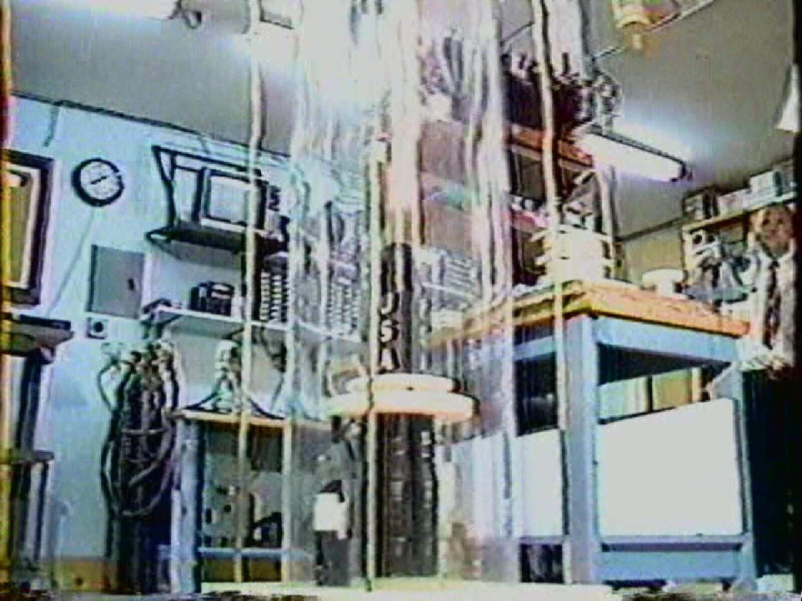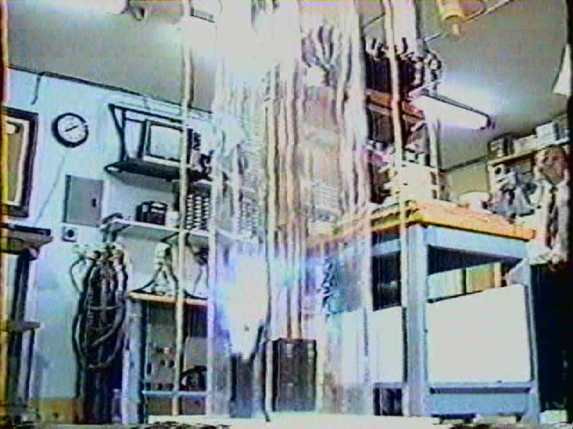

Mark Gray claims that some potential investors would ask “What good is this system if you have to have wires connected to projectile? That is not going to work”. So he developed this demonstration apparatus to show that the projectiles really didn’t need wires. Actually, they are needed for only a short distance, beyond which the magnitude of the repulsive forces drops off quickly. The above setup provided a sliding contact that is in the little black & white tower on the left of the larger black cylinder. This arrangement allows for about 6-8” of travel before electrical contact is broken. By that time, the traveling mass has received most of the shock impulse it is going to get. The black repulsing coils are composed of copper magnet wire that is about 2” deep. The outside is covered with black vinyl electricians tape. Mark also said that it was hard to reconnect the sliding contact because of rotation after a shot. Apparently it took a broom stick and a ladder to rest the demo.

COMMENTARY: The measurable voltage of the energy that propelled the small black cylinder on top with the (white plastic saucer on the bottom) was said to be 5KV. Now look at the length of the arc trail [about 12”] of the little contact tower (at the left) after lift off. Consider what kind of voltage was being generated at this point.

The State of the Storage Batteries prior to a test or demonstration for a Motor Cart

“When a motor cart was prepared for a test (or demonstration) both sets of batteries were fully charged”

COMMENTARY: So much for the idea of having to start with a dead battery. This theory comes from the idea that the lead-sulfite was the medium that might have converted a pulse of classical electricity into “Cold Electricity”

Another Cold Electricity Demo using the “Start Motor”

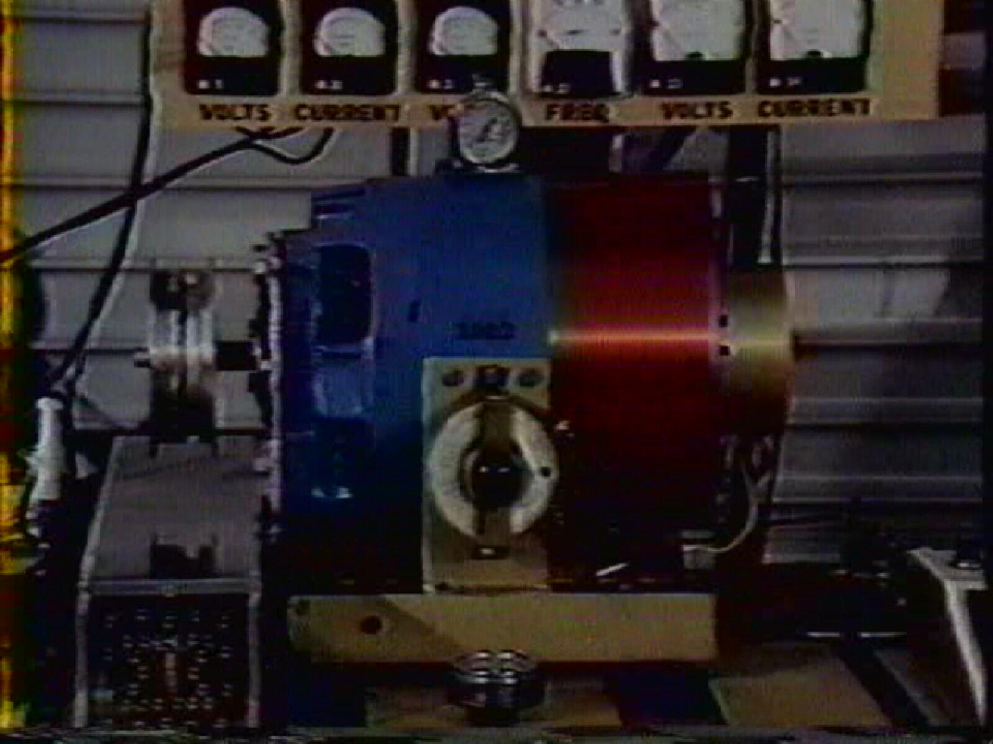

The white round dial instrument sitting on top of the “Start Motor” on the Multi-demonstration Cart is a thermometer, aka The Meter Cart. The other round dial instrument lying down on the table just below the round rheostat is a mechanical RPM indicator. [Biddle Meter]

The Importance of the Spark Gap

E.V. Gray told Mark Gary that the spark gap was very important.

COMMENTARY: A lot of other researchers think so to. (Including this author)

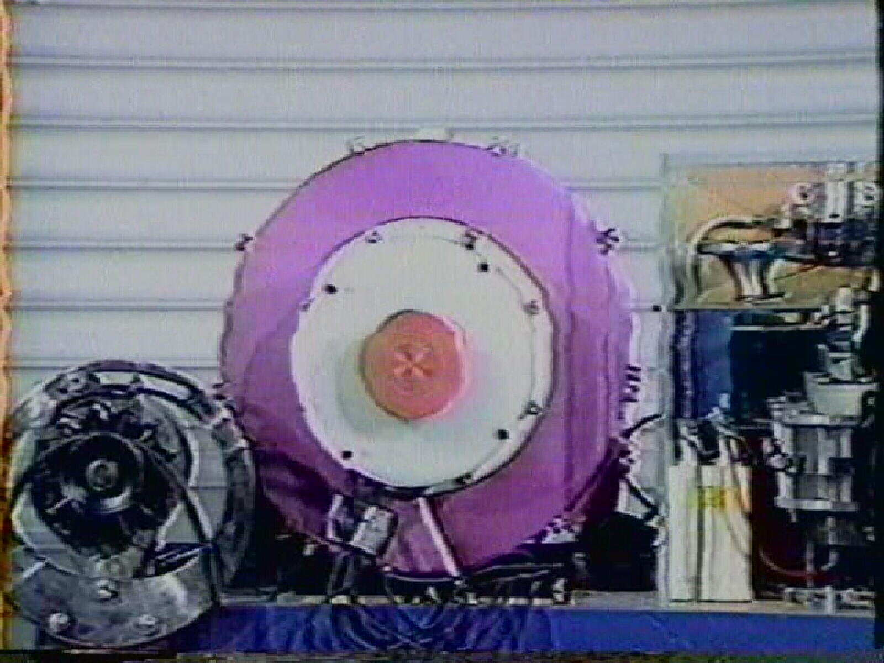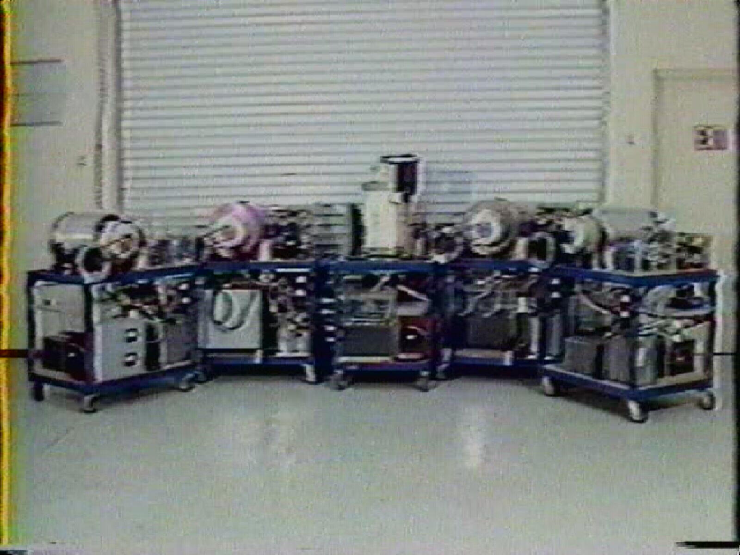
The Purple Motor A Family Group Photo

Motor Names:

While the older E.V. Gray motors were numbered, the newer versions in the 80’s were named according to a color. There was the Purple Motor [E2] , The Blue Motor [EMA7], The Brown Motor [E1], The White Motor [E5] and the Black Motor [E4]. Each one was intended to demonstrate some particular aspect of this technology or head off any common questions that had continually arisen over the years.

Stump the Expert Time:

Once, a professional researcher, from MIT, was allowed to examine the equipment while development was taking place in Canyon Country, CA, (Possibly for some investor review). He had flight arrangements to leave the following Monday and had the whole weekend plus a day for his investigation. Apparently there were no restrictions placed on what he could look at. This man was alleged to be one of the co-inventers who developed the first anti-shark repellants. He examined and observed for at least one whole day and then made a comment to the effect, “If I can’t figure this out, then all of my academic training is worthless”. He worked all through the weekend and left the following Monday with no tentative classical explanation.

COMMENTARY: If this reviewer had usable technical skills then this event implies that at that time (1980) E.V.Gray might have still hade some viable OU demonstration equipment still operating. It is unknown what that was or what became of it. All of the equipment displayed in 1986 appears to have been bogus.

Other Questions Asked through e-mail:

To your knowledge did your father (or his assistants) own or use any of these common electronics shop instruments?

Oscilloscope
Radio Frequency (RF) Generator
General Signal Generator
Pulse Generator
Transistor Tester
Q-Meter
Grid Dip Meter
Frequency Meter
Digital counter
Capacitor Tester
Battery Tester
Spectrum Analyzer
DC Power Supply

Of course any information about a general description, perhaps a Make and Model number (ha,ha), and an idea as to what the instrument was used for. When it was used and by whom.

Response 1) There were some meters involved, but I do not remember what meters might have been used or for they would have been used for.

2) The "kernel" of the technology appears to reside on the circuit trigger boards and the specific wiring to the off board components. From the photos we know that large power transistors were used. It is pretty obvious that other board components were used as well.

Do you happen to know what kinds of major components were on these boards? We can assume that there were a number of supporting resistors and small capacitors

Silicon controlled Rectifier (SCR)
Control Relays
Large Power Resistors
Transformers
Inductors or Chokes
Radio Frequency Coils
Vacuum Tubes
Diodes
Rectifiers
Power MOSFETS
Varisters
Potentiometers - Variable Resistors
Others
Model number of Power Transistors?

Of course a general description, approximate count, and any idea as to their function would be helpful.

Response 2) The most knowledgeable on the circuit boards may be Nelson 'Rocky' Shlaff (or Schlaff) from the Los Angeles area. I do remember that the circuit boards were developed in Canyon Country and for awhile the services of an electronics consultant was acquired to help development some of this circuitry. I do not remember the name of the consultant.

3) We know that you did a majority of the work on this equipment.

Was there any specific part of these "Carts" that your father reserved for himself to work on exclusively?

Response 3) Actually, my father did not protect any specific area of any of the technology that I can remember. Many people had cast their eyes on and all over the technology that was built. Nelson Schlaff and myself did most the assembly of the technology. There were others from time to time that were involved with the technology built.

4) Concerning the "Trigger Cart". You said that during its operation you would charge a certain capacitor to 5,000 volts before launching a projectile. You also said the voltage input was 220VAC.
Here are some general questions about the over all construction of the cart.

What Size Breaker was needed to power the "Trigger Cart" 30 Amp, 40 Amp, 50 Amp, higher?

Was a transformer use to raise the voltage from 220VAC to a higher voltage?

If 5,000 volts was the final measurable output voltage, then was there a higher voltage used somewhere else in the circuit that you know of?

Were Inductors or "Chokes" included on this Cart?

Did you ever have to make repairs on the "Trigger Cart", if so what was replaced and how often?

There are 4 "Ignitrons" on the Trigger Cart. Were all of these used at all times, or did different demonstrations use a different number of these devices?

Response 4) The only thing I remember about the voltage was charging the capacitors to 5,000v ?? for a one-time discharge (propulsion of a magnet), however, the hovering of magnets was achieved by a constant firing of the tubes.

5) Concerning the origins and nature of the transistor circuit boards used for the "converters".

Were these circuits made in house or contracted out? Did you make them? Did the design change over the years? If these boards failed who repaired them? Were replacements kept on hand?

Response 5) I do not recall much, if any was needed, maintenance on the circuit boards, nor do I recall having any made up as spares. I believe that all R & D and constructions of the technology happened in-house.

Closing Commentary:

Mark Gray provided valuable insights into the kinds of work that E.V. Gray was doing in the 80’s. He also provided the contact information to locate Nelson Schlaft “Rocky” who also shared a lot of the technical events for this same time period. After combining these two men’s testimony it became clear that the technical advancement had come to a stop with the death of Richard Hackenberger in 1980. All of the promotion videos were largely simulated demonstrations of a technology that once was. E.V.Gray continued on thinking that he still had “The power of Buck Rogers”. Well, he did, at one time but it was gone now. The Crosby verification tests were probably the keystone of his sales campaign, even though they documented the extraordinary power of this technology they didn’t provide any engineering detail, nor could E.V. Gray.

